TELink 700a/700n Factory Reset
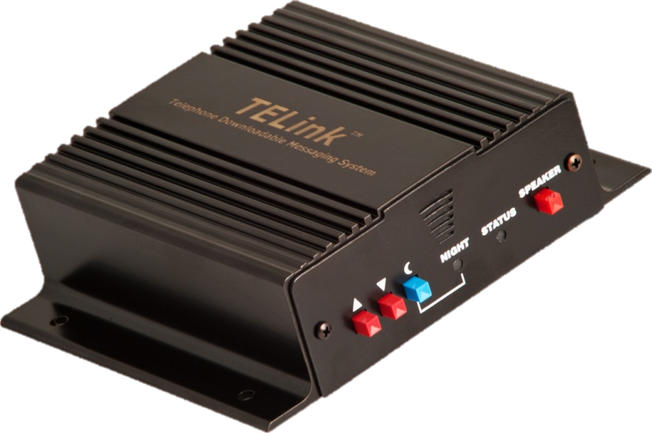

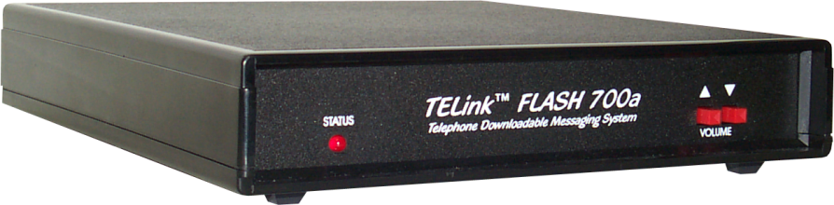
If you are having issues connecting to your 700a/700n TELink unit, follow the steps below to reset the unit. Before you do this, remember that this removes audio files from the unit and removes any customized settings, so until you connect back into the unit, fax share and audio are not available.

- Turn the unit off (either remove the power cord from the unit or use the power switch)
- Press and hold both the volume buttons
- Continue holding the volume button and restore power to the unit
- Wait for the Status LED to light up before you release the volume buttons
- Once done, the dealer can now call into the unit and upload new audio

